**User Engagement Metrics for Apps – Entertainment Sector**

Pooja Joshi & E.Code [E25007]

# Overview :

# This report focuses on analyzing user engagement metrics in the entertainment sector, specifically concerning app usage. The main aim is to examine the correlation between user engagement levels and key performance indicators such as attendance, sentiment scores, and frequency caps. By analyzing these metrics, the goal is to provide recommendations for optimizing user engagement strategies in entertainment apps.

# Objective:

* **Main Goal**: To analyze the relationships between engagement levels and metrics such as attendance, sentiment, and frequency cap.
* **Task**: To generate visualizations (bar charts and heatmaps) and derive insights from the data to suggest actionable strategies for improving engagement.

# Assigned Task(s) :

**Task 1**: User Engagement Metrics Analysis

* **Objective**: Analyze user engagement levels and their impact on attendance, sentiment, and frequency cap.
* **Task 2**: Visualization Creation
* **Objective**: Generate bar charts and heatmaps to understand the data better.

# Task Details :

**Task 1**: User Engagement Analysis

**Status:** Completed

**Details:** Analyzed user engagement levels and their relationship with attendance, sentiment, and frequency cap. The analysis included visualizations to help understand trends and correlations across these metrics.

**Task 2**: Data Visualization

**Status:** Completed

**Details:** Generated bar charts to visualize the distribution of average attendance, sentiment, and frequency cap across different engagement levels. Additionally, created a heatmap to observe the correlation between the numeric metrics.

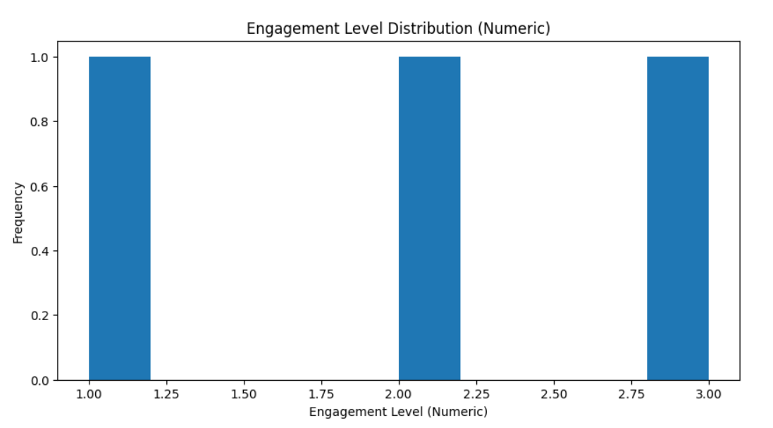

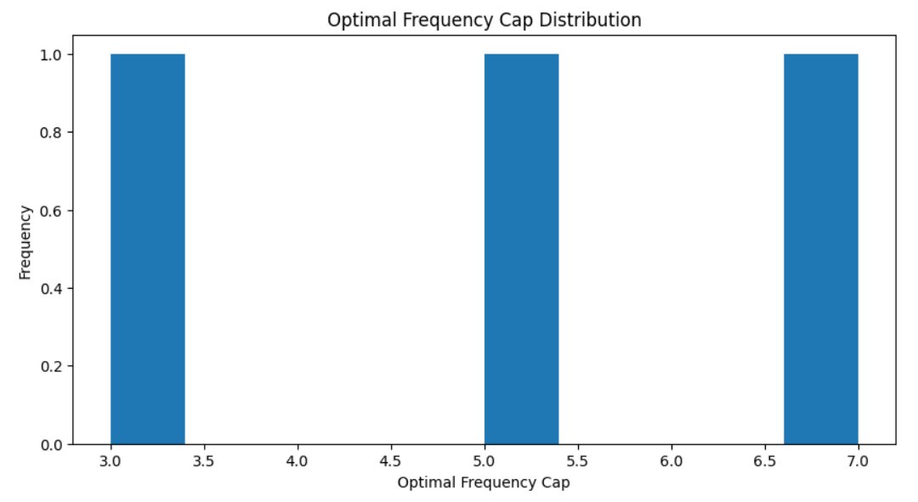

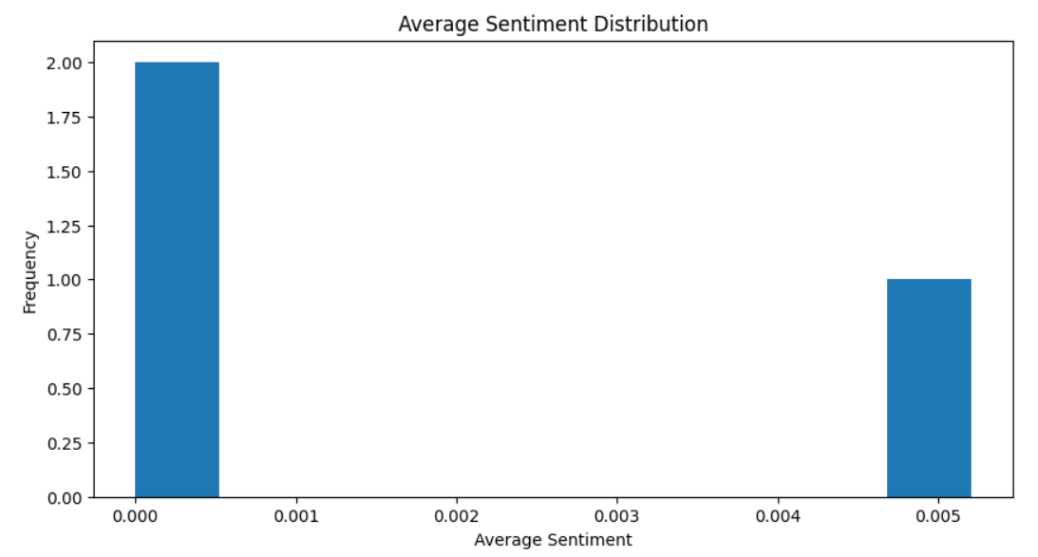

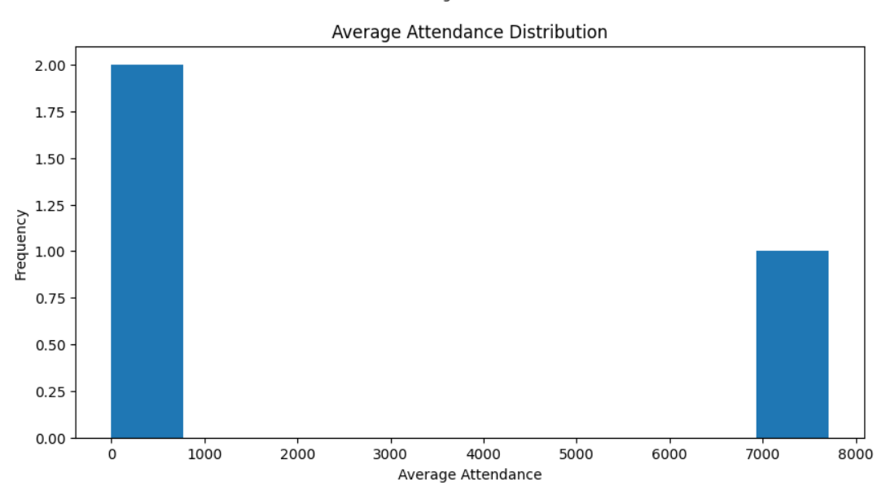

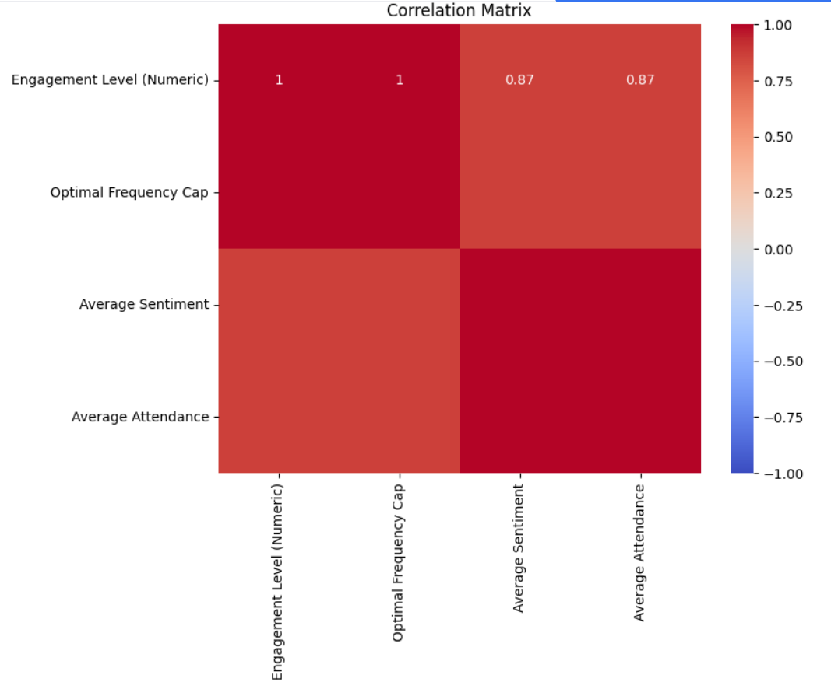

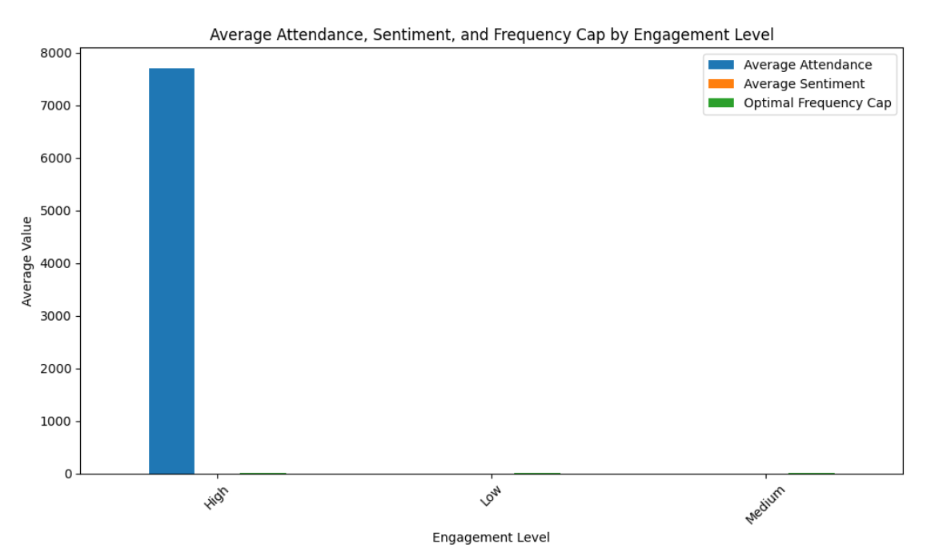

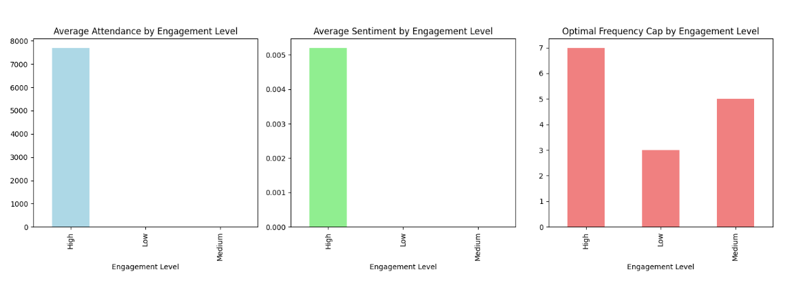

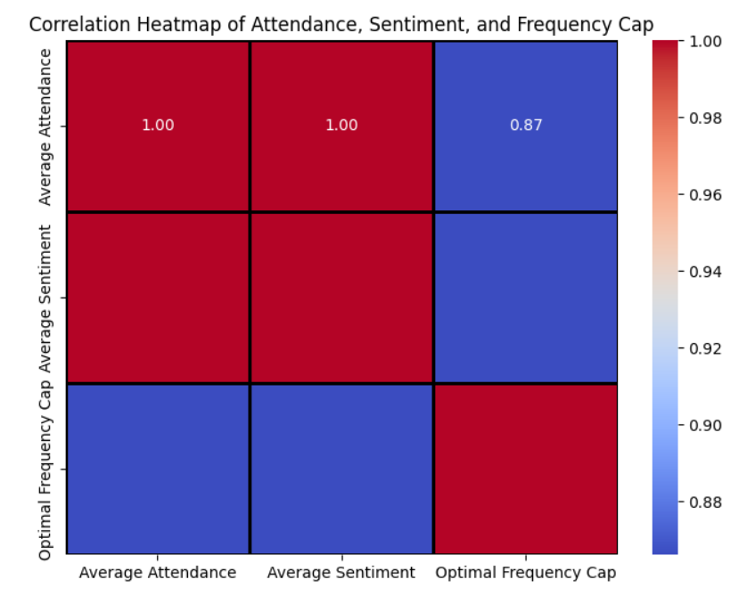

**Progress :**

· **Accomplishments**:

* Successfully completed the analysis of user engagement metrics.
* Generated clear visualizations to aid in data understanding and interpretation.
* Identified patterns and correlations between user engagement levels and other key metrics like sentiment and attendance.

· **Metrics**:

* **Bar Chart Insights**: Higher engagement levels correlated with better attendance and sentiment scores.
* **Heatmap Insights**: A moderate correlation between attendance and sentiment, and a slight correlation between attendance and frequency cap.

# Challenges and Solutions :

**Challenges Faced**:

* + Difficulty in interpreting sentiment scores for low engagement levels, as they often had inconsistent patterns.
  + Limited by available data for a deep dive into more granular engagement behaviors.

**Solutions Implemented**:

* + Cleaned data to eliminate outliers that could skew sentiment and attendance analysis.
  + Applied further data normalization techniques to ensure more consistent results.

**Next Steps :**

* **Upcoming Tasks**:
  + Conduct further segmentation of user engagement levels to understand their impact on specific audience types (e.g., high-frequency users vs. low-frequency users).
  + Investigate whether additional features, such as content types or platform usage, impact the engagement metrics.
* **Goals**:
  + Enhance user engagement by refining frequency caps based on the current findings.
  + Implement strategies to target users who show low sentiment but high engagement potential.

# Conclusion :

### Summary:

# The analysis successfully highlighted the impact of engagement levels on key metrics such as attendance, sentiment, and frequency cap. By creating visualizations and performing correlation analysis, we gained valuable insights that can help optimize content and engagement strategies.

# **Acknowledgments**: Thank the audience for their time and attention.